Planners: The Community Health Ministry Partners of West Michigan Education Team.

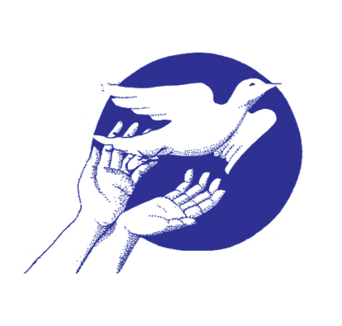

The mission of Community Health Ministry Partners of West Michigan (CHMP), a 501c3 organization, is to nurture and grow a community of faith community nurses who work individually and collectively to transform themselves and support each other in living lives of wholistic health; who serve as ministers of health and spirituality; and who advance the practice of faith community nursing.

Donations given to this organization are eligible for a federal tax deduction. Checks need to be made out to: CHMP WMI.

Session Topics & Objectives: At the completion of this session the participant will be able to:
AM: Embracing the Gifts of COVID:
- Explain the connection between the brain and prayer.
- Identify challenges encountered and gifts received from the pandemic.
Lunch: Nourish Your Body & Reconnect with Others
PM: Moving Forward – Care of Spirit and Self
- Experience focus and presence to the moment by using the body, mind and spirit to engage in prayer.
- Recognize ways we fail to care for
ourselves, and develop a list of self-care tools to change behaviors.

“Rest and self-care are so important.
When you take time to replenish your
spirit, it allows you to serve from the
overflow. You cannot serve from an
empty vessel.” Eleanor Brown

Community Health Ministry Partners of
West Michigan present

Do Not Let Your Hearts Be Troubled: Caring for Your Spirit and Yourself- Personally and Professionally

Thursday,
November 3, 2022
9 am – 2:30 pm
Trinity Lutheran Church
2700 Fulton St East
Grand Rapids MI 49506
616-949-2510

Contact Hours: 4.0 Contact hours have been applied for through the Calvin College Department of Nursing, a CCNE accredited nursing education program approved by the Michigan Board of Nursing. Contact hours may be awarded following attendance at the entire program and completion and submission of the evaluation form.

Target Audience: Faith Community/Parish Nurses (FCN/PNs) and RNs desiring fellowship and support of like-minded nurses with a spiritual focus to their practice.
Re-establishing a ‘community’ of FCNs and their RN friends. Need not be currently practicing FCNs. Please feel free to invite RN friends and colleagues.

AM Snack, Lunch & Beverages provided.

Dress: Comfortable, casual, conservative clothing is suggested. Room temperatures vary, so you may want a sweater or wrap.

Gather/Check In: 9 am
AM Program: 9:30 – 11:20am
Lunch: 11:20 – 12: 05 pm
CHMP Info Session: 12:20 – 12:25pm
Program: 12:25 – 2:15 pm
Evaluations/Adjourn: 2:15 – 2:30 pm
Fee: $ 40 per person
$ 35 each for 2 or more registering together in the same envelope
*Scholarships available upon request. Contact: scouzens77@gmail.com

Conference facilitator, Janene Ternes, is a Spiritual Director. She founded Prayer in
Motion, LLC in 2003 in order to provide opportunities for people to grow in their
relationship with God. Since then, she has developed and facilitated retreats throughout
the Midwest utilizing different forms of prayer. Janene’s mission is to help others
connect more intimately with God, leading to a more peaceful, joyful, and fulfilled life.
https://www.prayer-in-motion.com/
Janene has a certificate in Spiritual Direction from
Manresa Jesuit in Bloomfield Hills, MI and
earned her BS in Education Science from CMU.

Seating is limited – register early!
**After October 17th add $10.

Lunch and materials provided
only if paid registration received
BY October 17th.

No refunds.

You will receive email confirmation
of your registration.
If you have not received this confirmation
by October 21st,
please contact Suzan Couzens
616-443-5569

REGISTRATION: detach & mail
DUE BY October 17th

Name: _______________________________

Address: _____________________________
____________________________________

Preferred Phone: (H / W / C)
(______) _____________________

E-mail: ______________________________

Position/Title: _________________________

Church Affiliation: ______________________
Please wear your church ID badge.
Blank name tags will be available.

___Vegetarian ____Gluten Free

Specific food allergies______________________

Make checks payable to:
CHMP WMI
(checks made out otherwise cannot be
processed & will be returned)

Registration fee
___ $40
___ $35 (2 or more registering in same envelope)
___ $10 extra (per person) for late registration
___ Total enclosed

Return this form w/check to:
CHMP WMI
PO Box 64
Byron Center MI 49315-0064

Office Use Only:
Email confirmation sent ____
Date ____________

